Project Title

Initializing a Git Repository, Committing Changes, Pushing to GitHub, and Deploying a Personal Portfolio Website
AIM

The aim of this project is to initialize a Git repository, track and commit changes using Git, push the project to GitHub, and deploy a personal portfolio website using GitHub Pages or Netlify.
This project helps in understanding version control, remote repositories, and basic website deployment.

SOFTWARE / TOOLS REQUIRED

- Git (installed on system)
- GitHub account
- Code editor (VS Code / Notepad++)
- Web browser
- MS Word (for documentation)

Git is a distributed version control system used to track changes in files. GitHub is a cloud-based platform that hosts Git repositories.
GitHub Pages / Netlify are services that allow deployment of static websites. PROCEDURE / STEPS
PART A: Initialize Git Repository and Push to GitHub Step 1: Create Project Folder
- Create a folder named portfolio.
- Inside it, create a file index.html.

Should look something like:
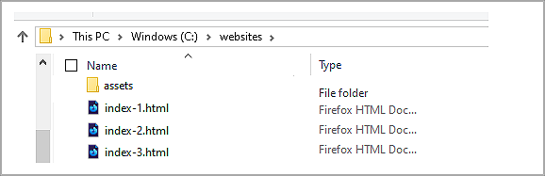

Step 2: Initialize Git Repository

Open terminal inside the folder and run:

git init
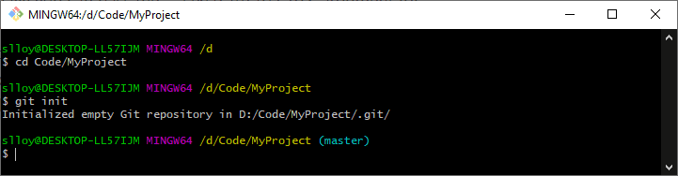

Step 3: Add Files to Git git add .
Below I have added a specific file. To add it all together, we use the above command.

Step 4: Commit Changes

git commit -m "Initial commit"

Step 5: Create GitHub Repository

- Go to github.com
- Click New Repository
- Name it portfolio
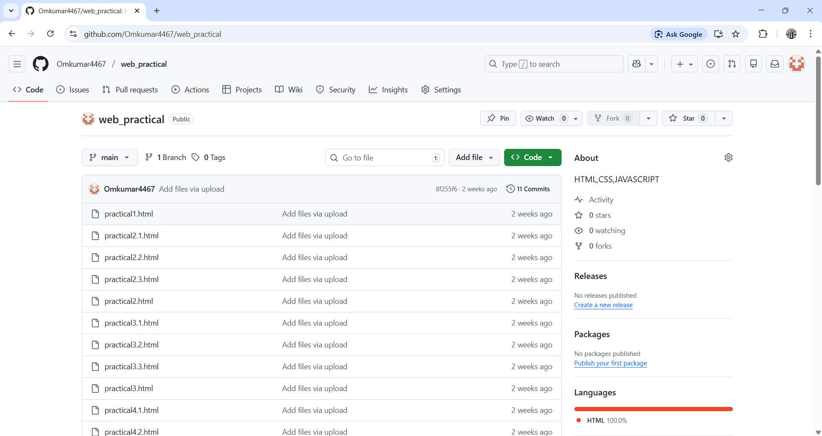
- Do NOT initialize with README

Step 6: Push Code to GitHub Run:
git branch -M main

git remote add origin <repository-url> git push -u origin main

PART B: Deploy Portfolio Website
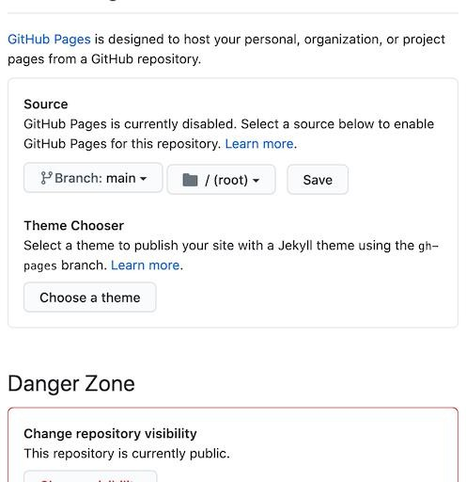
OPTION 1: GitHub Pages Step 7: Enable GitHub Pages
- Open repository → Settings
- Pages → Source → main branch
- Save.

Step 8: Access Deployed Website GitHub provides a live URL. Example output:


OPTION 2: Netlify (Alternative)
Step 9: Deploy Using Netlify

- Login to Netlify
- Click New site from Git
- Select GitHub repository
- Deploy site
